Church of the Holy Rood
Village Street,
Edwalton,
Nottingham.
NG12 4AB

Children and Families Pioneer

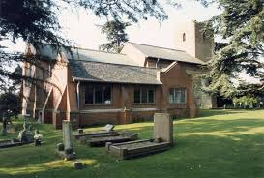

Full time (37.5 hours per week). Weekend working will be necessary including Sunday but hours can be worked out flexibly.
Starting salary £23,000 per annum (Pension, NI contributions and expenses will be provided.)
Closing Date : April 28th 2021 Short Listing: April 29th 2021
Interviews: May 6th 2021 Desirable start date:1st September 2021

Our Context
The Church of the Holy Rood Edwalton is at a significant point on its journey with many interesting opportunities emerging as part of its life and ministry. New housing developments within the parish which will eventually provide 1500 extra homes are underway, a deepening partnership with St. Luke’s Gamston (a neighbouring resource church), affirmation from the diocese about the direction we are heading and resources to invest in new facilities mean that we feel the time is right to step out and appoint a new full time Children and Families Pioneer.
Our Mission Statement

“A worshipping Church, welcoming young and old into the Lord’s family, proclaiming the gospel and serving the community.”

Our Vision:

By December 2025 and with God’s grace we seek to:

- Develop two thriving expressions of worship to serve the whole parish:

- Built on the best of our traditional heritage expressed with fresh energy and warmth for a 21st century community
- Informal, relaxed, contemporary worshipping community aiming to reach the newly established communities on the estate

- Operate a newly built church hall that serves the needs of the community and expresses the grace and truth that are in Jesus Christ.

- Deepen our relationship with St Luke’s to make most effective use of resources (people, processes, facilities etc)

- Resource an effective outreach to young families, led by an employed lay worker and supported by an enthusiastic team of volunteers.

Main Areas of Engagement for the Post
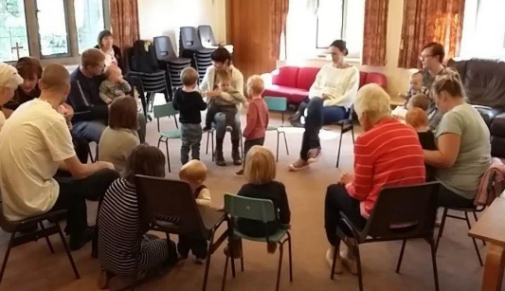
We are looking for someone who will prayerfully, lead the way in pioneering new initiatives which will encourage children, young people and families to explore faith and experience the transforming presence of Jesus.
We want someone who will create imaginative opportunities to engage in
conversation, build relationships with families out in the community and establish
places of hospitality e.g. through community sport, gardening activities, family fun days.

An important piece of the work will be
assessing the needs of children and families
in the community and exploring ways of
serving them.

Job Description

Main Duties and Responsibilities are:
- Make connections and network with local people and groups in Edwalton village and on the new housing developments in order to identify the main needs of the local communities and ways of addressing them.

- Pioneer initiatives on the new housing development that provide opportunities for engaging with people and building community which will also help to establish a healthy Christian presence there .

- Establish good relationships with Edwalton Primary School and Rosecliffe Spencer Academy, visiting regularly, volunteering, taking assemblies, leading clubs etc

- Build on the relationships established through the church toddler group and support the leaders as they make this a welcoming environment for families within the local community and signpost people to church activities.

- Explore opportunities for outreach to families through existing groups like Brownies, the Boys Brigade & Girls Association and develop appropriate new groups with evangelistic opportunities such as Messy Church, Open the Book etc

- Encourage exploration of the Christian faith by promoting and leading courses such as discipleship courses or courses on other relevant themes e.g. parenting.

- Work collaboratively with other local community groups and where appropriate develop joint initiatives for the wellbeing and flourishing of children and families.
- Make effective use of social media and online platforms to engage with the local community and promote church activities and Christian faith.

- Work with other church leaders to develop a mixed economy of worship styles across Edwalton Church and the new worshipping community on the housing developments to make services accessible and relevant to children and families

- Encourage the congregation to become involved in and support activities through volunteering their time, skills and funding.

- Support and encourage families to start and continue a journey into faith and relationship with Jesus Christ and work with the wider church leadership team to ensure children, young people and families are nurtured and deepen their faith.
- Participate in Sunday services, promoting family friendly content and an inclusive style, modelling innovative, engaging, Bible based teaching of the Christian faith.

- At all times work within the agreed policies of the church, including Health & Safety and Safeguarding policies and model good practice to others.

Person Specification

Essential :
- Have a living Christian faith and a clear commitment to the vision of the church
- Be pioneering, visionary and creative by nature, possessing the resilience needed to deal with set-backs
- Be confident in and passionate about sharing their vision for children and families and raising the profile of the church with others
- Demonstrate sensitivity and empathy towards children and families and have the desire to see God’s very best for families in every way
- Excellent networking and communication skills
- A leader and motivator of teams who thrives on working with others
- Leadership experience in a church or secular setting
- Be able to work effectively in a team and independently
- Proactive and committed to seeing projects through to completion
- Approach challenging situations with a positive mindset and be able to adapt to change
- Good time management skills with ability to prioritise a large and varied work-load
- Good administration, record keeping and organisational skills
- Good IT skills and comfortable with the use of social media platforms
- Pastoral sensitivity and discretion
- Experienced in children’s and families’ministry
- Have a clear understanding of good safeguarding practice

Desirable:
- A relevant qualification in community or youth / children’s work
- A minimum of 2 years’ experience in community work or families work
- Experience of engaging families in both church and non-church environments
- Experience of school’s work
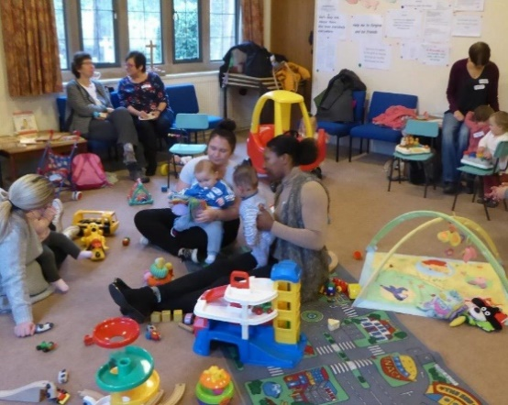
There is a genuine occupational requirement that
the post-holder is a Christian and is happy to
worship in a Church of England context.

This post is also subject to an enhanced DBS disclosure
and satisfactory references.

Under the terms of the Data Protection Act, the
information supplied by the successful candidate
as part of the application will be kept as part of
their personnel file.

We can only consider UK citizens or those who have right of residence and the right to work full time in the UK

Working requirements & remuneration:
- Hours : 37.5 hours per week (subject to negotiation)
- Starting salary: £23k
- Contract: Permanent contract with a 6 month probationary period
- Will be or become an active member of Edwalton Church
- Working week: flexible as agreed with line manager to include Sundays, some evenings and occasional Saturdays Also, Christmas and Easter.
- Holidays: 25 days + 8 statutory days annual leave (including up to 5 Sundays) Time off in lieu if it is necessary to work statutory holidays.
- Statutory workplace pension will be paid.
- Attendance at a regular staff meeting including meeting and networking with the St. Luke’s staff team
- Subject to annual appraisal and objective setting

Support, Training and Development

The post holder will have the opportunity to access a range of networks and develop opportunities. S/he will work closely with a new curate who is joining the leadership team and whose focus will be on developing a new worshipping community on the new housing developments. In addition the Children and Families Pioneer will be able to attend joint staff meetings with St. Luke’s Gamston providing the opportunity for networking, support, development of ideas and joint initiatives. St. Luke’s is a resource church with a growing staff team that includes a Children and Families Worker.

Holy Rood Church is part of the Diocese of Southwell and Nottingham who place specific emphasis on Children’s and Young People’s ministry as expressed in their mission statement which is Growing Disciples wider, younger and deeper. At the moment they have an intentional focus on developing this area of ministry and have recently launched an exciting new strategic initiative. In partnership with the organisation ‘Rebuild’ they are setting up new Youth & Children’s Ministry Learning Communities. It is hoped that the post holder would engage with one of these learning communities.

