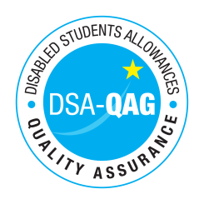
Moorlands College - NMH Rates

The table below shows NMH rates. The greyed out cells indicate that the NMH provider does not offer these services.

Note: NMH Support Rates shown per hour in the table below.
 | Standard Rate (in-person) |  |  | Distance Learning only (in-person, in-home |  |  | Remote Delivery (e.g. Facetime/Skype or similar) Only
Band 4 Specialist Access and Learning Facilitators | NET | VAT | Total |  |  |  | NET | VAT | Total
Specialist Mentor – Mental Health | 54.50 | 0 | 54.50 |  |  |  | 54.50 | 0 | 54.50
Specialist 1:1 Study Skills Support - SpLD | 54.50 | 0 | 54.50 |  |  |  | 54.50 | 0 | 54.50
Specialist 1:1 Study Skills Support – ASD | 54.50 | 0 | 54.50 |  |  |  | 54.50 | 0 | 54.50
*Please delete any rows where you do not provide this support role

